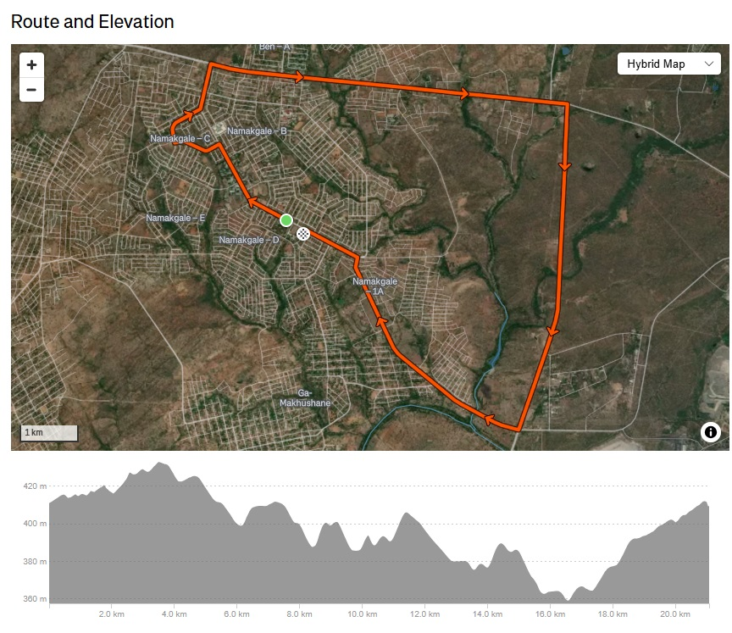

# ROUTE DESCRIPTION F-21 HALF-MARATHON NAMAKGALE

1. At the Foskor Community Centre signboard on Calvin Ngobeni Drive. (Dummy start 10m (E) of the actual start line.) Run NW along Calvin Ngobeni Drive. Road bears N at 0.8km.
2. Just before Zakes Ngwasheng Drive opposite College. Continue N along Calvin Ngobeni Drive. Turn left (W) at Mavis Malatjie Street. Sign Missing
3. By house 386 before bend. Turn right at T-junction into Phumolong Avenue. Bears right (E).
4. On bend by bus-stop 30m before the (derelict) Lerato Bar. Turn left (N) into Calvin Ngobeni Road again. (WATERPOINT 1)
5. 50m before cattle grid by “60” sign. Turn right (E) into National Road (R71) to Phalaborwa.
6. By new “Bollanotto” buildings on right. Continue E on R71.
7. 80m past Maputha Malatji turnoff by sign. Continue E on R71. (WATERPOINT 2)
8. About 250m before Cellphone tower on right opposite ZWIDE walled property on left. Continue E on R71.
9. Opposite ROCK VIEWER sign. Continue E on R71.
10. By Marula trees before culvert. Continue E on R71. (WATERPOINT 3)
11. 20m before Lulekani turn off before Lydenburg road (R530). Turn right (S) onto R40.
12. Near new 36.2km signpost opposite kopje. Continue S on R40.
13. Near new 35.2km signpost. Continue S on R40. (WATERPOINT 4)
14. Near new 34.2km signpost. Continue S on R40.
15. Near small tree opposite before culvert. 33Km signpost missing Continue S on R40.
16. By old 32km signpost. (WATERPOINT 5) Turn right (W) towards Namagale at crossroads. (Makhushani Drive).
17. About 100m after intersection. Continue towards Namakgale.
18. After crossing bridge start running uphill. Km mark by Marula tree on right. Continue towards Namakgale.
19. About 30m before banner structure across road opposite “castle” house. (WATERPOINT 6) Continue towards Namakgale. Road bears right.
20. By middle of open un-used field near electricity pole NMA 25/9 on right. Continue towards Namakgale. (WATERPOINT 7 at about 19.5Km)
21. 5m before the intersection, before stop sign. Turn left (NW) towards Central Namakgale into Calvin Ngobeni Drive at intersection with Makhushani Drive.
22. By Stop sign at intersection (Madiba Street) by Foskor Community Centre, 30m before gate peg.

21.1 70m from the gate peg on the field.