**MAMRE ATHLETIC CLUB**

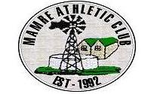

**MAMRE 21.1KM ROAD RACE**

**5KM FUN RUN/WALK**

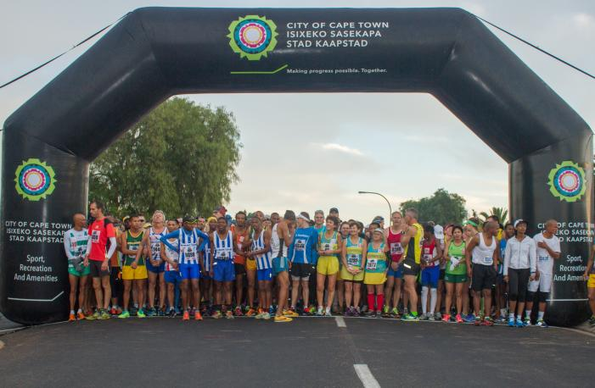

**COCA- COLA LEAGUE EVENT**

**SATURDAY 24th JUNE 2023**

**MAMRE PRIMARY SCHOOL**

**21.1km 08h00 am**

**5km 08h15 am**



** **

**THIS EVENT IS HELD UNDER THE RULES AND REGULATIONS OF, ASA AND WESTERN PROVINCE ATHLETICS & ORGANISED BY MAMRE ATHLETICS CLUB**

ENTRY FORM

***RACE DISTANCE***  **Plea Please Tick**

**5KM**

**21.1KM**

**60-69**

**50-59**

**40-49**

**20-39**

**16-19**

**U16**

**70+**

**AGE CATEGORY:**

**ID NUMBER:**

**FEMALE**

**MALE**

**AGE:**

**Y**

**Y**

**Y**

**Y**

**M**

**M**

**D**

**D**

**D.O.B**

**SURNAME:**

**FIRST NAME:**

**PROVINCE:**

**2023 LICENCE #:**

**CLUB:**

**NO**

**YES**

**DO YOU BELONG TO A RUNNING CLUB?**

**EMAIL:**

**CELL #:**

**TEL: (W)**

**CODE:**

**SUBURB:**

**ADDRESS:**

**SHOE BRAND:**

**NIKE**

**NEW BALANCE**

**BROOKS**

**ASICS**

**ADIDAS**

**OTHER**

**SAUCONY**

**REEBOK**

**PUMA**

**EMERGENCY CONTACT PERSON**

**CONTACT #:**

|  |  |
| --- | --- |
| **EVENT:** | **ENTRY FEE** |
| **21km Licensed Athlete** | **R150** |
| **21km Unlicensed Athlete** | **R220** |
| **5km Fun Run/Walk** | **R50** |
| **Masters 70 + Free for licensed runners** | **R70 Temp runners** |

**Medical Aid Number**

**Medical Aid Name**

**Indemnity and Waiver: I …………………………………………………..agree not to hold the Mamre Athletics Club, ASA, WPA, sponsors, or any persons assisting in the organizing of the race liable for any injury or illness, which I may suffer directly or indirectly as a result of participating in the race. I confirm that this Special Agreement is entered into for the benefit of the Mamre Athletics Club event, the sponsors and the persons assisting in the organizing of the event.**

**Signed:…………………………………………………………..Date………………………………………**

**Signature of parent or guardian if under the age of 18**

**HOW TO ENTER:**

* **ONLINE: Enter online at** [**www.topevents.co.za**](http://www.topevents.co.za) **(should you have any enquiries about entering online, please contact Top Events on email** [**info@topevents.co.za**](mailto:info@topevents.co.za)**. Closing date for online entries is Sunday 18th June 2023.**
* **RACE DAY: Entries will be taken on race day from 06h00 at the Mamre Primary School in the hall.**
* **A 10% service fee will be charged when entering online.**

**CONFIRMATION OF ENTRY:**

* **When entering online please be sure to add in your email address to receive your confirmation email.**
* **This email needs to go with you to number collection on 24th June 2023.**

**NUMBER COLLECTION:**

* **Number collection for online entries will be on 24th June 2023 at the Mamre Primary School from 05h00.**

**START TIMES:**

* **21km: Will start at 08h00am**
* **5km: Will start at 08h15am**

**CUT OFF TIMES:**

* **21km - 3 Hours 30 Minutes**
* **5km - 1 Hour**

**PRIZE MONEY SCHEDULE: (Men and Women)**

|  |  |  |  |
| --- | --- | --- | --- |
|  | **1ST PLACE** | **2ND PLACE** | **3RD PLACE** |
| **OPEN** | **R1300** | **R900** | **R800** |
| **40 – 49** | **R650** | **R550** | **R500** |
| **50 – 59** | **R650** | **R550** | **R500** |
| **60 – 69** | **R650** | **R550** | **R500** |
| **70+** | **R650** | **R550** | **R500** |
| **TEAM** | **(Open) Men** | **(200x 4)** |  |
|  | **(Open) Women** | **(200 x 4)** |  |

**Spot prizes at prize giving at 11h30 in the Mamre Primary School Hall.**

**RACE RULES:**

* **The Mamre 21km is open to all licenced and non-licenced runners of 16 years and older.**
* **2023. Licence numbers must be worn on the front and the back of the vest.**
* **Temporary licences will be available at registration, R70. When registering, participants must complete and hand in the tear off strip from the number in order to be eligible to compete.**
* **Temporary licenced participants are eligible for age category prizes provided they enter the relevant age group, wear the appropriate age tags and provide proof of age.**
* **Unlicensed runners must wear plain clothes (no advertising permitted) and the temporary licence on the front of the vest.**
* **No personal seconding will be permitted except at official refreshments stations.**
* **No Race numbers will be issued**
* **Do not litter. Dispose of sachets and cups responsibly by using the boxes provided or carrying them to the finish. Report offenders to the referees.**
* **Detailed rules are available on** [**www.wpa.org.za**](http://www.wpa.org.za) **or on request from the organisers or WPA office.**
* **For safety reasons the use of personal music players with headphones is not allowed. Use of such a device may result in disqualification.**
* **Ensure that your club name and licence number are filled in on your entry card.**
* **In addition to overall (Open) prizes, participants will only be eligible for an age category prize in the age category they enter. Corresponding numerical age category tags must be worn (40, 50, 60.etc.) on the front and back of their club vest. Participants may enter the age category corresponding to their chronological age or any younger category down to senior.**
* **Wheelchair athletes must please contact the organisers timeously to discuss arrangements for their participation.**
* **Athletes competing for a category prize must wear age category tags (on the front and the back).**
* **Licenced runners must wear club colours to qualify for team prizes.**
* **No swopping of WPA licence numbers is allowed this will result in your disqualification and possible disciplinary action.**
* **Juniors must provide proof of age to qualify for prize money.**
* **Juniors (born in 2004 or later) wearing a junior or senior licence must display “J” age category tags to qualify for age group prizes.**
* **Entry race cards must be in athletes possession at all times during the race.**
* **All traffic officers and marshals must be obeyed.**
* **Proof of age is required for category prizes.**
* **The race organisers reserve the right to accept or reject any entry.**
* **Kilometre markers will be placed at each kilometre mark**
* **Refreshments stations will be situated approximately every 3km.**
* **The first 10 men & women will receive gold medals, 11 –100 men & women will receive silver medals 101-1000 will receive bronze medals.**
* **There will be a tog bag facility available. Organisers and Mamre Athletic Club members will not be held responsible for loss or damages. Do not leave valuables or cash in your bag.**
* **Toilets will be available.**
* **Parking is available on the school grounds.**

**5km Fun Run/Walk Children:**

* **Children under 10 years must be accompanied by an adult. Prams allowed, but no pets. Medals to all Finishers of the Fun Run. License not required for Fun Run.**
* **The fun run will finish at 09h15 and spot prizes available.**
* **The fun run does not count for the Coca Cola league.**

**DIRECTIONS TO MAMRE VIA N7 AND R27**

## h

## ROUTE A (via N7)

1. **Follow N7 until Philadelphia/ Stellenbosch/ Atlantis turn-off (intersection) about 1km passed the ENGEN SWARTLAND 1-STOP.**
2. **Turn LEFT and continue until T-junction (Tree Lane- R304)( Atlantis)**
3. **Turn RIGHT, continue until STOP (+/- 6.5km), go over to the next STOP (+/- 200m further) NB!! Landmark: Saxonwold Supermarket and road connection to/from Malmesbury on right hand side of the stop.**
4. **Continue with tree lane over a third stop (Witsand informal Settlement) and continue over 2 traffic circles to the first 4way stop.**
5. **At 4way stop turn RIGHT and continue through Atlantis over four 4way stops. NB!! LANDMARK: K F C right hand side of 1st 4way stop.**
6. **Follow 21km road signs past Silverstream road and LEFT into Main road to Mamre.**
7. **Follow marshals instructions into entry area.**

**ROUTE B (via WEST COAST ROAD/R27)**

1. **Follow R27 past the Melkbos traffic lights until Atlantis/Mamre turn-off 7km/14km sign.**
2. **Turn RIGHT and continue with road past Atlantis (on your Right) until T-junction and STOP sign.**

**3. Turn LEFT at T-junction, follow nrs 6 and 7 above.**

**Event contact details:**

**Claire Nel (0846099869) Lesley Daniels (0791116489) Tania Bartes (0747077555)**

**Thanks to our sponsors**

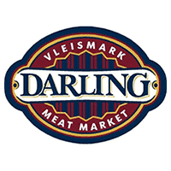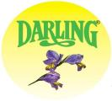

**MAMRE BUTCHERY**